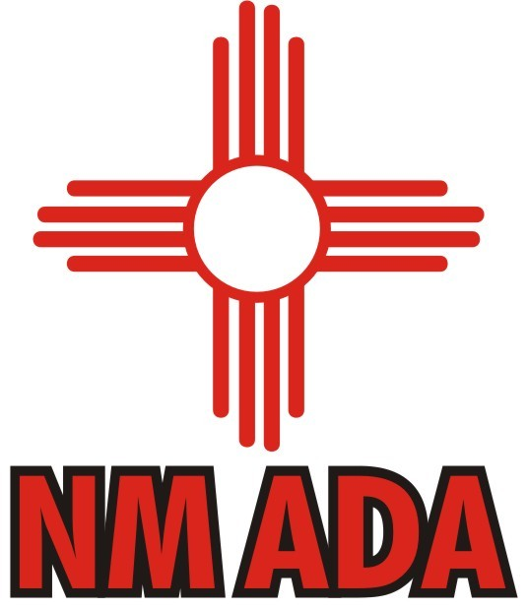 NMADA RECOGNITION/SCHOLARSHIP APPLICATION 
PLEASE PRINT OR TYPE - PLEASE READ THIS PAGE CAREFULLY

NMADA APPLICATION for CERTIFICATE OF RECOGNITION - ONLY
♦ This application is for high school senior athletes only
♦ Application must be submitted by an athletic director that is a member of the NMADA
♦ The application information page must be completed and signed for all student-athletes
♦ This form must be submitted on/or prior to Tuesday, February 28, 2023
♦ Transcripts, letters of recommendation, vita sheet and essay are NOT REQUIRED TO
RECEIVE JUST A SCHOOL RECOGNITION CERTIFICATE.
♦ ALL APPLICANTS WHO COMPLETE APPLICATION FORM WILL RECEIVE A CERTIFICATE. Those certificates will be sent to the School Athletic Director in April.
♦ Complete the application form if you wish the student-athletes to receive only the school recognition certificate and not be eligible for the scholarship

NMADA SCHOLARSHIP APPLICATION (Please print or type on application)
CRITERIA: (All the following must be submitted to be considered for a scholarship)
♦ Athletic Director must submit a packet with completed application form and all documents
♦ Be a New Mexico H. S. Senior projected to graduate during the 2022-2023 academic year
♦ Exhibited excellence in academics
♦ Exhibited excellence in at least one area of athletic participation
♦ Multi-Sport, school activity, and/or community service participation are selection criteria
♦This form must be completed and signed by all appropriate parties
♦ Submit an official transcript with 7 semester grades reported with school GPA and rank
♦ Submit a 1 page résumé /vita sheet should include: Honors and achievements in sports, other school activities participated in, school honors, civic or community activities.
♦ Athlete: Submit an essay explaining: “What are the Valuable life lessons that Athletics teach.” “How has athletics affected you as a student-athlete participating in athletics/activities?” The effect of athletics on your teammates, your coaches, your school, and your community?
♦ Submit 1 letter of recommendation
♦ Other activities / civic involvement may be used as part of the selection criteria and process

SELECTION PROCESS:
♦ All Information must be submitted by the Athletic Director
♦ Athletic Director must be a member of the NMADA
♦ All signatures must be affixed, and documents attached
♦ All documents must be received on/or prior to Tuesday, February 28, 2023
♦ Each school is allowed to recommend ONLY one male and one female student-athlete
♦ Only listed information requested will be accepted and considered
♦ DETAIL AND COMPLETENESS OF APPLICATION IS IMPERATIVE
♦ A committee of NMADA Officers and Board members will select the scholarship recipients
♦ Submit all documents & forms to:
Mail to: Larry Waters, NMADA Scholarship Committee
8204 Loma Del Norte NE, Albuquerque, NM 87109 or e-mail to: ljh2os@aol.com Phone: 505-221-2144 or Fax to: Tammy Richards, NMAA Fax: 505-923-3114 (NMAA)
♦ Selections and Scholarship information will be announced and all nominated candidates will receive Recognition certificates.
♦ The NMADA will provide Scholarships for one male and one female New Mexico athlete in the amount of $_1,500__each

♦ A parent signature is required for all nominations to give the NMADA permission to release information to the media
NEW MEXICO ATHLETIC DIRECTORS ASSOCIATION
SCHOLAR-ATHLETE NOMINATION FORM Due by Tuesday, February 28, 2023

►COMPLETE THIS FORM FOR THE SCHOOL RECOGNITION AWARD AND SCHOLARSHIP

SCHOOL: _______________________________

ATHLETE’S NAME: ____________________________________ GENDER: ⁯ MALE ⁯ FEMALE

HOME ADDRESS: ____________________________________CITY:__________________ ZIP__________

PARENT/S: _________________________________________________________________________________

HOME PHONE: _____________ CELL PHONE: _________________EMAIL: __________________________

SPORT PARTICIPATION / HONORS EARNED (Additional information may be detailed in the résumé)
SPORT: _________________________ VAR. LTRS: ________ HS YEARS OF PARTICIPATION: __________
HONORS AWARDS ______________________________________________________________________________
________________________________________________________________________________________________

SPORT: _________________________ VAR. LTRS: ________ HS YEARS OF PARTICIPATION: __________
HONORS AWARDS: _____________________________________________________________________________
________________________________________________________________________________________________

SPORT: _________________________ VAR. LTRS: ________ HS YEARS OF PARTICIPATION: __________
HONORS AWARDS: _____________________________________________________________________________
________________________________________________________________________________________________

SPORT: ________________________ VAR. LTRS: ________ HS YEARS OF PARTICIPATION: __________
HONORS AWARDS: _____________________________________________________________________________
________________________________________________________________________________________________

ACADEMIC ACHIEVEMENTS (Additional information may be detailed in the résumé)
7 SEMESTER GPA:________ RANK:____/______ ACT SCORE:_________ SAT:_________

HONORS/AP CLASSES: __________________________________________________________________________

ACADEMIC HONORS: ___________________________________________________________________________
________________________________________________________________________________________________

OTHER ACTIVITIES / CIVIC INVOLVEMENT (Additional information may be detailed in the résumé)

SCHOOL INFORMATION
PRINCIPAL: _______________________________ ACTIVITIES DIRECTOR: __________________________
►ONE LETTER OF RECOMMENDATION (attached)
FROM: _________________________________ POSITION/TITLE: _____________________________________

*ATHLETIC DIRECTOR: _______________________________ PHONE/CELL: ________________________

*Must be NMADA Member: #__________ EMAIL:_______________________________________

SIGNATURES

ATHLETE: ________________________________ PRINCIPAL: ________________________________

PARENT: _________________________________ *ATHLETIC DIR: _____________________________

